NOCSOBI identified a team to put a proposal together for the UKPACT funding application under the theme: “Advancing a just and clean energy transition through local action”.

The meeting took place in Cape Town on the 29^{th of} July 2025

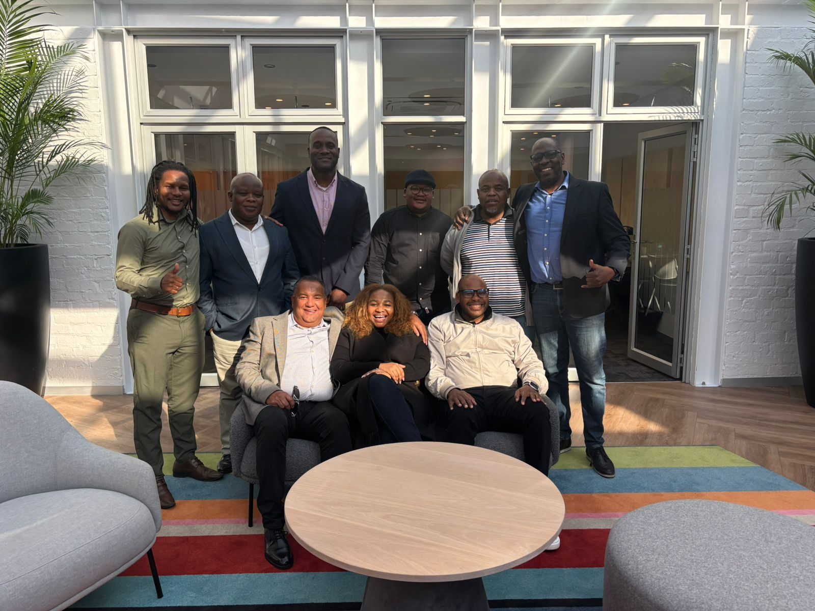
Back row (left to right): Mr Wanga Mbasa – NOCSOBI Board Member, Mr Bernard Mabele – NOCSOBI Acting CEO, Mr Pavel Parks – Director at AGET, Mr Tebogo Selao – NOCSOBI Board Member, Mr Mzi Ngcakani – Branch Manager at Mekan Engineering Services and Mr Moses Ngobeni – NOCSOBI Interim Board Chairperson

Front row (left to right): Mr Jeremy Arenz – AGET Subcontractor, Mrs Zanele Modiba – Director at the Alternative and Mr Simi Masina, SIMDAR Co-founder.

